TITLE PAGE

**Patterns of influence in wild moving meerkat groups**

Baptiste Averly1,2,3, Vivek H. Sridhar2,3, Vlad Demartsev1,2,3,4, Gabriella Gall1,2,3,4,5, Marta Manser4,5,*, Ariana Strandburg-Peshkin1,2,3,4,*

1. Department of Biology, University of Konstanz, Konstanz, Germany
2. Department for the Ecology of Animal Societies, Max Planck Institute of Animal Behavior, Konstanz, Germany
3. Centre for the Advanced Study of Collective Behaviour, University of Konstanz, Konstanz, Germany
4. Department of Evolutionary Biology and Environmental Studies, University of Zurich, Zurich, Switzerland
5. Kalahari Meerkat Project, Kuruman River Reserve, Northern Cape, South Africa

*joint senior author

**ABSTRACT**

**INTRODUCTION**

In wild social animal groups, movement is a particularly critical behavior during which a number of constraints apply (Conradt and Roper 2005). On one hand, individuals within a group need to remain cohesive to retain the benefits of communal living, such as predator avoidance or increased foraging efficiency, and avoid the costs associated with becoming isolated. At the same time, decisions have to be taken regarding direction and timing of travel, with party members likely to differ in motivations, due to heterogeneous status, physiological states, or personalities, creating conflicts of interests (Conradt and Roper 2010; Delgado et al. 2018). To resolve this paradox, while fully democratic processes where every individual participates in every decision exist (REF), most of the time certain individuals initiates an action and other individuals respond to it. According to the nomenclature defined by Strandburg-Peshkin et al. (2018), such initiators can be said to have influence if their actions in a given instance cause others to change their behavior, while they can be defined as leaders if they have repeated influence over multiple instances. Influence is therefore a trait which can be expressed in a number of ways, depending on the type of cues from an initiator that are followed by other individuals; this can include position in space, movement in a given direction, specific vocalizations… It is often not easy to disentangle which of these cues are of particular relevance for followers and thus to know how to infer influence patterns in moving animal groups.

In addition, different types of decisions likely entail different influence processes. For instance, decisions regarding direction of movement (“where to go”) are often discontinuous, because individuals have to choose between discrete locations, whereas decisions regarding timing (“when to go” or “how fast to go”) are continuous. Consequently, sharing of decisions regarding direction is predicted to evolve in groups with low conflicts of interest between members or with high cohesion benefits, whereas it is the opposite for timing decisions (Conradt and Roper 2010). Different species are thus expected to exhibit different patterns of influences between group members, based on traits like social structure, movement characteristics, foraging habits… How influence is distributed is also likely to vary between groups of the same species, or in time within a single group, depending on changes in environmental and social contexts, or in individual motivation along with their physiological status or foraging success. Influence is therefore a very versatile trait which requires a thorough understanding of the species’ biology to assess accurately.

In recent years, there has been a surge in studies aiming to assess influence dynamics in wild moving animal groups, thanks to a reduction in cost and size of tracking technologies allowing the simultaneous recording of multiple individuals (Hughey et al. 2018). Common methods include looking at who is in the front of the group (), who is being followed when initiating group movement (Strandburg-Peshkin et al. 2015) and correlating direction of movement between individuals (Nagy et al. 2010). Many times, managing to collect data on several groups within the same species, or evaluating the relevance of the measured metric for inferring influence (for instance, the assumption that individuals more in the front are leaders ) remains challenging. In addition, the diversity of ways in which influence can be expressed means that methods are often highly system-specific, but recent theoretical frameworks have encouraged comparisons between studies by providing a common terminology (Garland et al. 2018; Strandburg-Peshkin et al. 2018). The assessment of influence dynamics in as many social systems as possible is crucial if we want to understand both general mechanisms and diversity of collective decision-making.

Meerkats *Suricata suricatta* are social mongooses living in the arid parts of southern Africa. Meerkat groups, composed of up to 50 individuals, are highly cohesive with members sleeping inside communal burrows during the night and continually moving as a cohesive unit throughout their 2-5 km2 territory (Kranstauber et al.) in search of food during the day. Group splits may happen very rarely (Strandburg-Peshkin et al. 2020) and never last more than a couple of hours (REF?). Meerkats are opportunistic generalists, their diet being mainly composed of small invertebrates that they dig out of the ground (Doolan and Macdonald 1996), therefore food resource is not clumped like for several other social species (Ref capuchins, dolphins,…?) but rather distributed across the desert landscape. This particularity is reflected in the groups’ movement dynamics: rather than alternating clearly distinct foraging and moving phases, most of time the group as a whole is slowly travelling across the environment in a cohesive manner, despite all individuals foraging independently a few meters apart form each other. Discrete initiation of group movement do also happen, mainly through the use of specific calls (Bousquet et al. 2011). Meerkats indeed have a highly developed vocal repertoire (Manser et al. 2014) and calls have been shown to play an important role in maintaining cohesion (Gall and Manser 2017) or in mechanisms of shared decision-making (Bousquet et al. 2011), but a lot remains unclear about how influence is distributed among group members during movement. Though meerkat groups are socially structured with two dominant individuals monopolizing most of the breeding, and no strong social hierarchy between subordinate group members, there are few evidences that dominance status also translates to more influence during non-breeding activities such as foraging (Bousquet et al. 2011; Gall et al. 2017; Strandburg-Peshkin et al. 2020). Their particular social structure and movement dynamics, make meerkat an interesting model species to further our understanding of the diversity of collective movement mechanisms in the wild.

Here, we introduce and implement a simple method to infer individual influence in moving animal groups by explicitly differentiating influence over direction and over speed of travel, and contrast it with the proportion of time spent in the front of the group. We use a dataset of very-high resolution GPS tracks of wild habituated meerkats in 5 different groups of varying sizes. We aim to answer three primary questions: (1) Are there particular individuals of particular statuses with more influence over others during movement, and are these patterns consistent across groups? (2) Are meerkats more influenced by the position or the movement of other more influential individuals ? (3) Do individuals which have high influence over direction of movement also have a lot of influence regarding speed and vice-versa?

**METHODS**

**Study site and data collection**

*Study system*

The study was conducted at the Kalahari Meerkat Project (KMP) within the Kuruman River Reserve in South Africa (26°58′S, 21°49′E, Clutton-Brock et al. 1999) , where 7-15 meerkat groups are highly habituated to humans and monitored on a daily basis all year round. We collected the data during winter months on five distinct habituated meerkat groups: HM17 (7 individuals) in August and September 2017, HM19 (18 individuals) in June and July 2019, L19 (19 individuals) in August 2019, ZU21 (13 individuals) in May 2021 and NQ21 (11 individuals) in August 2021. We chose the groups with the highest levels of habituation among the monitored population so that we could collar them easily. Individuals were attributed one of six different statuses, based on ongoing classification at the KMP: dominant females (one per group), dominant males (one per group), other adults (2+ years), yearlings (<2 years), sub-adults (<1 year) and juveniles (<3 months). Three individuals were present both in HM17 and HM19, with different statuses.

*Tag design*

To simultaneously record the trajectories of all individuals in a meerkat group, we designed small (<25 g) collars consisting of a GPS unit (Gipsy 5, Technosmart, Colleverde, Italy) and its battery (ER14250M) fixed on 5 mm-wide leather strap and protected from shocks and sand by wrapping in parafilm and covering with 2-part epoxy glue. The length of the strap was adjusted individually for each meerkat based on prior neck measurements we had collected beforehand. The closing mechanism consisted of 2 magnets (1*5*5mm) glued to 3-D printed plastic clasps at each end of the leather strap, designed to be able to close easily but to require human intervention to open. Completed collars weighed between 22 and 25g, which was never more than 5% of the wearer’s body mass. Once fitted on a meerkat, the GPS board rested on back of the neck, with the whip antenna pointing down the back of the individual (Figure 1a).

*Collar deployment, duty cycle and retrieval*

In winter months (May to August?), meerkats typically spend up to an hour in the morning at their communal sleeping burrow before moving off to forage. During this time, they are typically relaxed and often stand upright in the sun to warm up or groom one another, thus presenting an ideal opportunity for non-invasive collar deployment. To deploy collars, one person would slowly approach a meerkat and start grooming its neck to test receptivity. If the target remained stationary and showed no sign of discomfort, the person would then try to clasp an appropriately-sized collar around its neck, stopping if the meerkat recoiled or moved away. To collar some individuals, a second person presented a water bottle to distract them, and the collar was clasped around the outstretched neck of the drinking meerkat. After two failed attempts for a given individual, it would be left alone for the rest of the day to prevent any risk of de-habituation. After successful collaring, individuals were observed for at least ten minutes and the collar was removed if they exhibited any kind of unusual behavior. This happened in very few cases, always on the smallest individuals. At the end of data collection, collars were taken off much in the same way as they were put on, though sometimes as well during foraging since removal could be done much more quickly and easily than deployment. Juvenile individuals were too small to wear a collar, therefore their movement could not be recorded. All GPS units in a given group were synchronized to start on the same day and to record at 1 GPS fix/second for 3 hours every day, either in the morning after the group had left the sleeping burrow, or in the afternoon before returning to it depending on the deployment round. These are times when meerkats are foraging freely within their territory and are usually the most active. Recording duration for a single deployment round ranged from 6 days to 10 days depending on GPS-battery life.

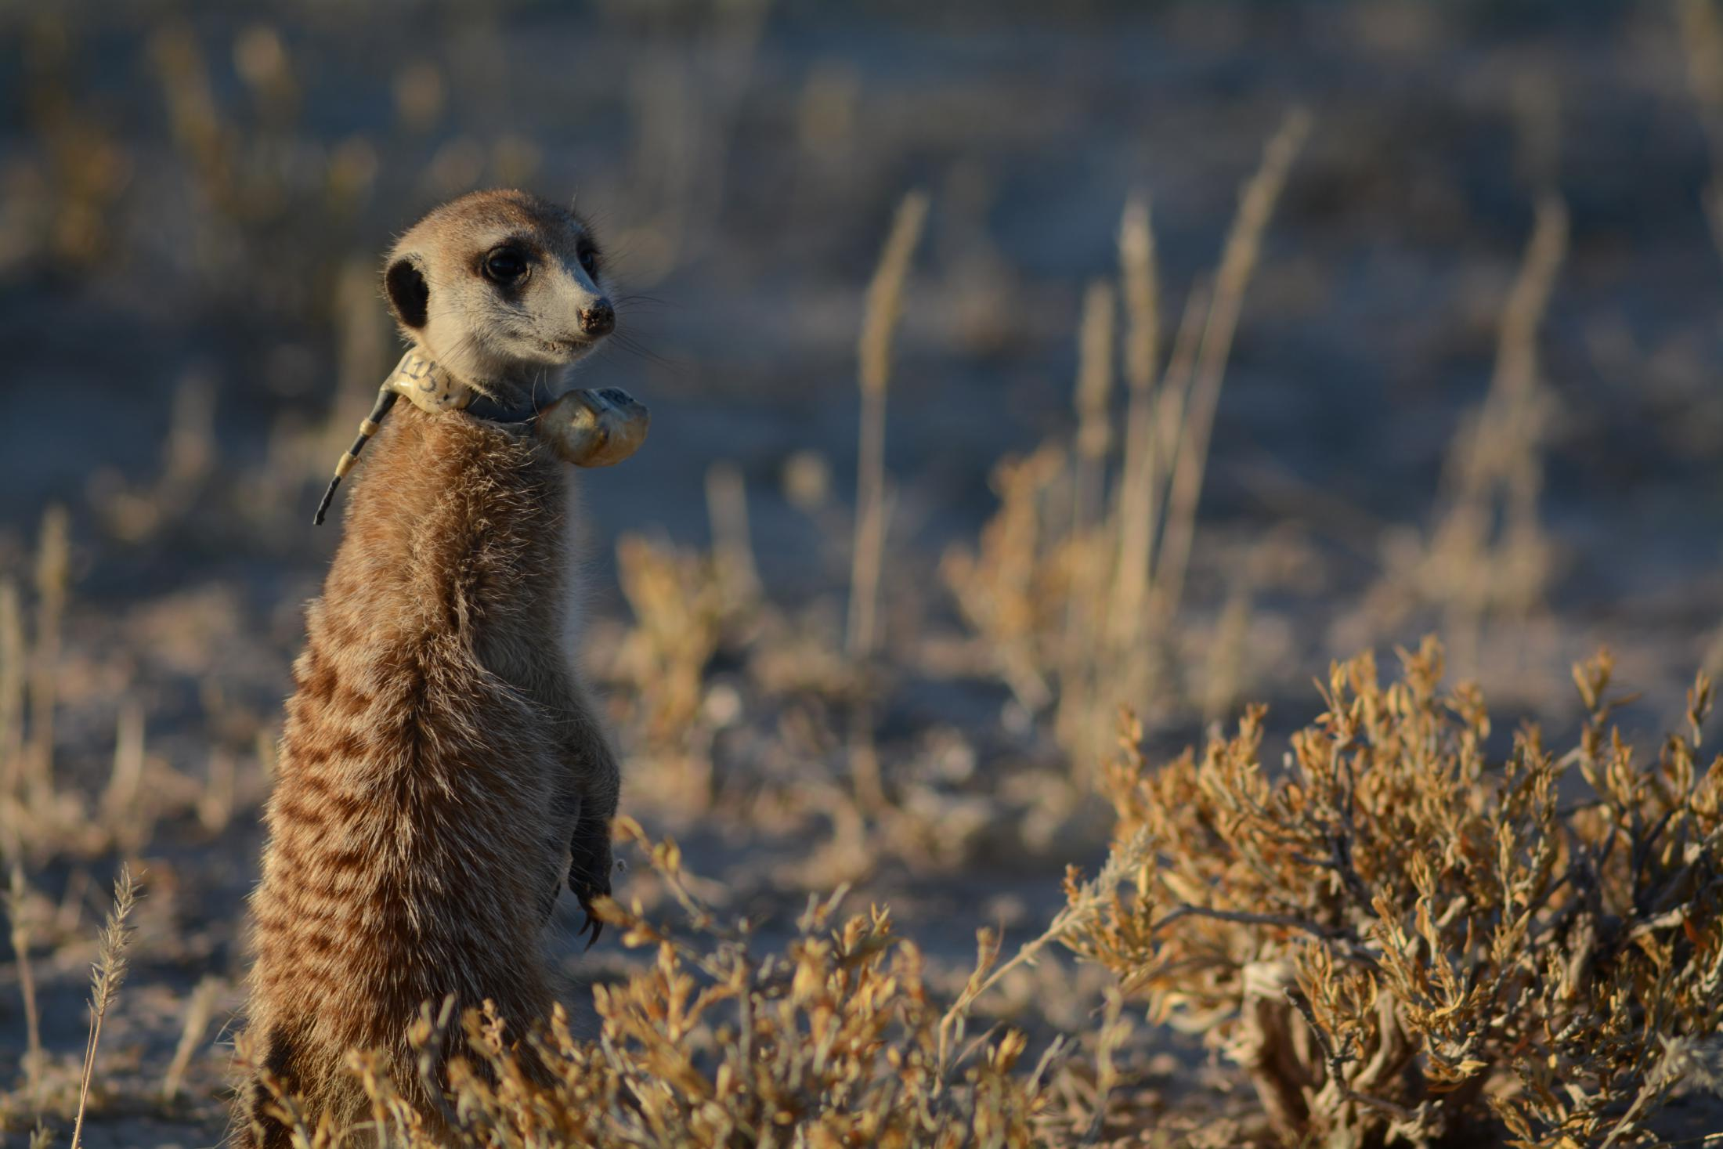

**battery**

**GPS**

**unit**

**antenna**

*Focal recordings of untagged individuals and scans*

Some non-juvenile individuals that could not be collared via the methods described above were instead continuously recorded by a human observer. A GPS tag equivalent to those deployed in collars was strapped to the end of a telescopic pole and thus kept within 1 meter of the foraging meerkat for the duration of each session. We then then processed the data of the uncollared exactly in the same way as data from meerkats wearing a collar. Another person performed scans by noting in a tablet when specific events would happen on an all-occurrence basis (predator alarm, encounter with another group, etc…). The numbers of meerkats which could be focal-followed depended on the number of persons available (never more than 3), therefore not every non-juvenile could be recorded on every day, especially as GPS tags started failing due to low battery towards the end of the deployment round.

*Data pre-processing*

To increase GPS reliability and reduce sampling biases we pre-processed the data before subsequent analyses:

When GPS signals were not recorded continuously we discarded all fixes taken 30s before signal loss and 30s after retrieval. Similarly, we removed fixes with fewer than 5 satellites detected.  We also removed data suggesting unrealistic speeds, e.g. a distance of more than 10 m between 2 one-second fixes, as these likely represented GPS errors. Coordinates were converted from WGS84 to UTM S34 to allow for easier spatial analyses.

Moments where less than 2/3 of the non-juveniles present were recorded were removed to reduce the impacts of “invisible” individuals.

Specific contexts likely to be non-representative of typical meerkat group movement during foraging were removed. These included predator alarms and encounters with other groups (identified using scan data) as well as group splits (standard deviation of all the inter-individual distances at a given moment larger than the 90% quantile over all time points for this group).

**Analysis**

Calculating movement characteristics (figure 2):

* The centroid track was computed by averaging the position of all individuals recorded at any moment in time. At any moment in time, the velocity vector (direction and speed) of the centroid was calculated from its position 10 meters in the past, as well as 10 meters into the future
* At any point in time, the position of each individual, as well as their velocity vector to 10 meters into the future, were calculated relative to the group’s past direction of travel.

We first calculated groups’ and individuals’’ movement characteristics by discretizing and summarizing the direction and speed of their travel (Fig. 1). A **group’s centroid track** was computed by first averaging the position of all individuals recorded at each time point. For every time point, we then calculated two velocity vectors of the centroid: the past velocity vector was the direction and speed measured from that time point’s position to the most recent position that was at least 10 meters away, and the future velocity vector was the direction and speed measured from that time point’s position to the soonest upcoming position that is at least 10 meters away. For each time step, the movement of the group was defined as either turning left or turning right, and either speeding up or slowing down, based on the relative difference between the group centroid future velocity vector and past velocity vector. The group centroid’ past velocity vector was also used to define an orthonormal basis relative to which the position and movement of all individuals could be compared. For this, we also calculated **individual’s tracks** in the same way as the group centroid track: we calculated the past and future velocity vectors for each individual at each time point.

In order to assess how individuals’ movement affects the movement of the group as a whole, we compared groups’ centroid tracks with individuals’ tracks. We defined the following metrics likely to reflect patterns of influence:

* **Time in front**: the proportion of time spent by a given individual in the front half of the group (relative to the group’s past direction of travel). This reflects influence on the assumption that leading individuals should be more often in the front of the group.
* **Turning influences**: two metrics to measure the probability that the group’s direction of movement is influenced by a given individual. At any time t, the group’s future direction of travel (relative to its past direction of travel) was binarized as either turning left or turning right. We then looked at the probability of the group turning right as a function of an individual’s left-right position at time t (**position turning influence**) and an individual’s left-right speed at time t (**movement turning influence**). See figure 2 below. One advantage of this methods is that it could potentially identify individuals leading from the back of the group.
* **Speeding influences**: two metrics to measure the probability that the group’s speed is influenced by a given individual. At any time t, the group’s speed (relative to its past speed) was binarized as either speeding up or slowing down. We then looked at the probability that the group had of speeding up as a function of an individual’s front-back position at time t (**position speeding influence**) and an individual’s front-back speed at time t (**movement speeding influence**)

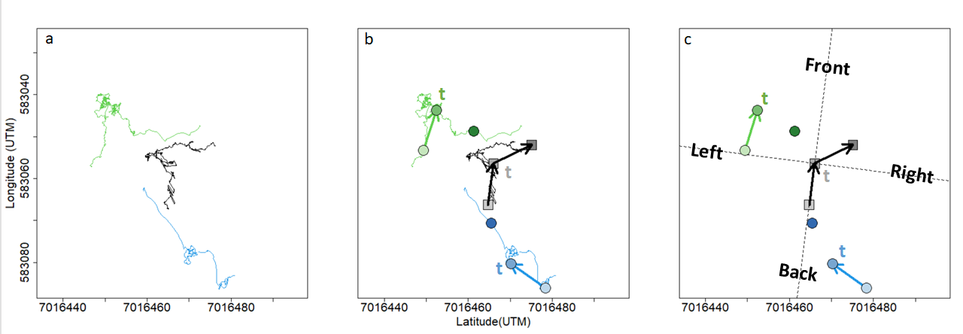

Figure 1 Summary of data processing for a given time point. (a) Portions of meerkat movement trajectories collected from GPS collars. Green and blue lines represent the trajectories of two example individuals over a 20 minutes interval. Black line represents the trajectory of the group centroid over the same time-interval, obtained by averaging the coordinates of every individuals in the group (only two individuals represented). (b) At time t, velocity vectors are calculated from the points 10 meters in the past and 10 meters in the future. Lighter symbols represent positions earlier in time, darker ones represent symbols later in time. (c) The velocity vector of the centroid from the past is used to define an orthonormal basis (dashed line) relative to which the position and movement of all individuals are calculated. Based on the centroid velocity vector from the future, the group is defined as either turning left or turning right, and either speeding up or slowing down at time t. Influence metrics are derived from the individual velocity vectors from the past. In this example, the blue individual would have a positive position turning influence at time t because it was on the right side of the group before the group turned right, but a negative movement turning influence because it was moving towards the left before the group turned right. It is the opposite for the green individual.

Modelling turning and speeding influences:

The four measures of influence were modelled by a modified version of the logistic function, allowing the curve to have horizontal asymptotes before 0 and 1:

The variable x represents one of the four individual metrics of influence that we test: position along the left/right axis, speed along the left/right axis, position along the front/back axis, and difference with centroid speed along the front/back axis. F(x) is the outcome of the group decision, either the probability to turn right (position turning influence, movement turning influence) or the probability to speed up (position speeding influence, movement speeding influence).

The first term of the equation (in red) represents the probability that the group decision (either turning left/right or speeding up/slowing down) is influenced at time t by a given individual, with probability alpha. This term corresponds to a standard logistic function equation.

The second term (in blue) represents the probability that the group picks the decision at random, with a probability (1-alpha).

Therefore, a higher value of alpha indicates a higher influence of that given individual on the rest of the group.

We fitted a curve separately for each individual, for each of the 4 influence metrics, by maximizing the log-likelihood (figure 2). Then each curve was synthetized by an influence score taken to be the y-value for a given, fixed value of x (90% quantile across each individual).

We performed GLMM on these influence scores with status as a categorical predictor and group as a random effect to test if there were consistent differences between the influence of each status.

…What about the 5th influence metric? ‘time in front’? how is this calculated, compared, modelled, etc?

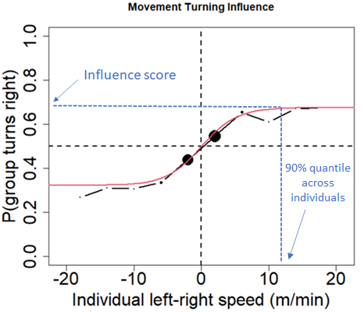

Figure 2. Example for one given individual of the probability that the group turns right relative to its past direction of travel as a function of that individual speed along the left-right axis. Positive x-values indicates that the individual was moving towards the right of the group relative to past direction of travel, negative values indicate it was moving towards the left. Black curve shows the real data (binned every 4 x-units), red curve shows the fitted line from the modified logistic function, blue dotted lines shows how the influence score is found for that individual.

**RESULTS**

**Which individuals spend more time in the front of the group?**

We found the proportion of time spent by each status in the front half of the group relative to direction of travel to be relatively variable between groups (figure 3). In 3 out of the 5 groups (HM2017, HM2019 and NQ201), the dominant female spent a much greater proportion of time in the front than any other individuals. However, in L2019, 6 individuals spent slightly more time in the front than the dominant female, even though she was overall more often than not in the front. In ZU2021, the dominant female was by far the individual spending the highest proportion of time in the back half of the group. In all groups except L2021, the dominant male was usually in the back half of the group. There were no overall trends for the other statuses.

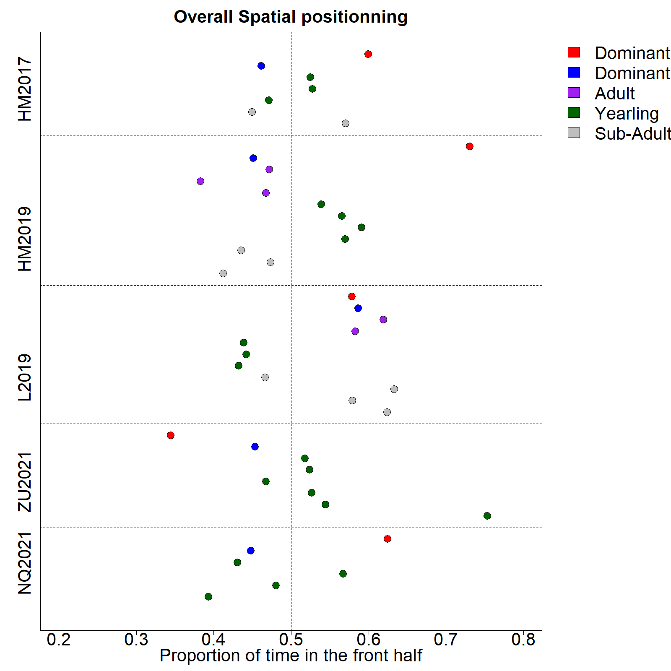

Figure 3. Proportion of time spent in the front half of the group relative to the group’s direction of movement by each recorded individual (colored dots) in the 5 study groups (vertical axis). Dot color indicates individual status as shown in the legend.

**Is the group more influenced by the position or the movement of individuals?**

We modelled the probability of the group turning right relative to its past direction as a function of each individual’s position and movement along the left-right axis of travel (position and movement turning influence), and the probability of the group speeding up relative to its past speed as a function of each individual’s position and difference to group speed along the front-back axis of travel (speeding influence). Across all groups, we found a logarithmic relationship whereby group probability to turn right increases sharply as individual movement towards the right increases, before plateauing (figure 2 and figure 4a). Likewise, group probability to speed up increases as individual’s speed relative to the centroid’s, along the axis of movement, also increases (movement speeding influence; figure 4b). Individual position along the left-right and front-back axis of movement is also positively correlated with the group probability to turn right or speed up respectively, but to a much lesser extent than their movement. We therefore mainly focus the rest of our analyses on the movement version of each type of influence (movement turning influence and movement speeding influence).

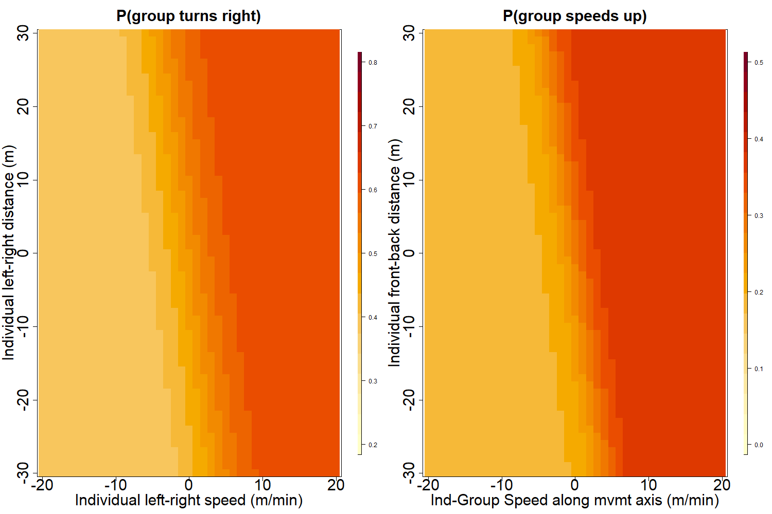

Figure 4. (a) Turning influence: Predicted probability that the group turns towards the right relative to its past direction of movement as a function of individual position and movement along the left-right axis of travel. (b) Speeding influence: Predicted probability that the group speeds up relative to its past speed, as a function of individual position and group-individual difference in speed along the front-back axis of travel.

**How much do different individuals influence direction and speed of movement of the group?**

Based on the fitted logistic curves of movement turning influence and movement speeding influence, we attributed a score to each individual for both influence metrics, representing respectively the probability that the group would turn towards the same side this individual was moving to, or would speed up after the individual had sped up toward the front of the group. There was a significant effect of status on the turning influence score (figure 5a, F = 6.76 ; DF = 35 ; p-value = 0.0004), with the dominant female’s score being overall much higher than that of any other status. There was no significant difference between the speeding influence score of different statuses (figure 5b, F = 0.88 ; DF = 35 ; p-value = 0.48).

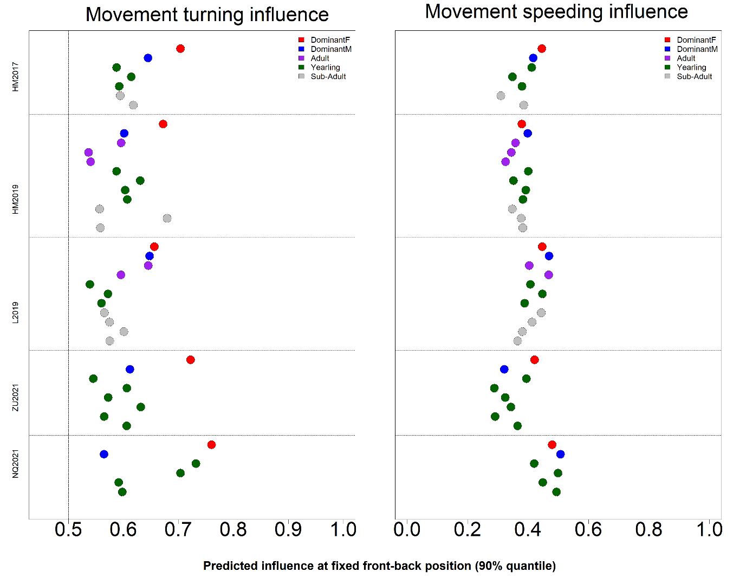Figure 5. Predicted influence scores for each recorded individual (colored dots) in the 5 study groups (vertical axis). Dot color indicates individual status as shown in the legend. (a) Turning influence score represents the probability that the group turns toward the same direction (left or right) that individual was moving to. (b) Speeding influence score represents the probability that the group speeds up after that individual had sped up towards the front of the group.

**DISCUSSION**

In this study, we analysed simultaneous movement trajectories of most individuals in social groups of highly cohesive meerkats while foraging. We measured the average position of each individual along the group’s axis of movement, as well as their probability to influence the rest of the group’s direction and speed of travel, in order to infer the patterns of influence among social statuses. The comparison of 5 different groups as well as the use of different, complementary metrics to measure influence, allows us to draw nuanced conclusions regarding mechanisms of coordination and social cohesion in meerkats.

We found that overall, the movement of individuals is more important in predicting which direction the group is going to go next, or when it will accelerate, than their position within the group. Though classical models of collective movement (REF) or controlled studies of moving animal groups (REF) often find individual position to be an important predictor of where other individuals are going to be moving next, our findings make sense in the light of the particular ‘stop-and-go’ type of movement exhibited by meerkat groups. Indeed, contrary to animals in the studies cited above which tend to be always in motion and for which therefore position is a strong indicator of direction, a lot of the time each individual meerkat is foraging independently from others while the group as a whole is relatively stationary, therefore their position in the group doesn’t necessarily entail the direction where they want to go next. Rather, as our results indicate, their likelihood to influence the group’s direction of movement increases with the speed at which they move towards that particular direction. This exemplifies how important the type of movement exhibited by a collective group are in determining the decision-making rules they follow.

When looking for consistent differences between status across our 5 study groups, it appears that the dominant female sticks out from the other categories: she has indeed significantly higher turning influence across all groups, meaning that the rest of the group is much more likely to move towards the same direction where she just moved to, than any other statuses. The dominant male is on the other hand not significantly more likely to attract the other members of the group than the remaining status categories. This pattern is likely explained by the fact that meerkat group territories vary little within the course of their existence (REF), so individuals who have spent more time within a given group are therefore the most experienced ones in terms of navigating within this group’s home range, and should thus be more likely to be followed by other less experienced individuals. Indeed, dominant males, though often older than their female counterpart, are usually dispersers who grew up in a different group than the one they end up “dominating”, while dominant females don’t disperse and are usually the eldest individuals to have been born in their group (REF). This is the case for all 5 groups we studied here, with the exception of NQ21, where 2 subordinate individuals were born in the same litter as the dominant female, and it is noteworthy that they too had substantially higher turning influence scores than other individuals in their group. It is however surprising that we found no differences in influence between subordinate statuses (non-dominant adults, yearlings, and sub-adults), as according to our reasoning older statuses would be expected to have more influence. It is thus likely that knowledge of the home range, in combination with dominance status, are traits significantly contributing to increase a meerkat’s high influence on the group’s direction of movement.

There was no significant difference in speeding influence between statuses, meaning that different social statuses had a similar chance of speeding the group up when they were moving faster than the centroid, or slowing it down when moving slower than the centroid. The dominant female therefore seems to have more of a say over the direction of travel of the group, rather than its speed, for which the decision is likely more distributed among individuals. Conradt and Roper (2010) predicted that shared decision-making on activity timing was likely to evolve either in social groups where the benefits of group cohesion was low, or where the cost of consensus was high (some individual paying a high price for agreeing on the decision of others). In meerkats, the former can be ruled out as survival chances are drastically reduced for lone individuals (REF). However, individuals within a meerkat group differ substantially in terms of their physical conditions, energy requirements or foraging success, and in addition, the main timing imperative for meerkats is likely to be getting back to one of the sleeping burrows distributed throughout their territory before night falls. Therefore, during the day, successful individuals might pay a low price if the group stays longer in a given foraging patch, but unsuccessful or more needy ones would on the opposite suffer a high cost if the group departs too early, on the decision of one or a few influential individuals. It would then make sense that decisions regarding speed of travel would be shared across individuals, depending on their specific need at a given moment. Quorum mechanisms, akin to a voting process by which a certain threshold of individuals giving a specific type of call is required for the group to start moving, has already been shown in meerkats (Bousquet et al. 2011), and it would be interesting to study how this mechanism relates to individual foraging success. Contrary to timing decision, wrong decisions regarding the direction of movement could end up being very costly for all individuals in the groups, as they could end up in a location with little food, or no sleeping burrows, or in rival territories. Thus, it makes sense that leaders are more likely to emerge in decisions involving directions, in the traits of more experienced individuals like the dominant female.

The tendency to be in the front of the group is often taken as a proxy for leadership in studies of collective animal movement. Here, in 3 out of the 5 groups we studied, the dominant female was spending much more time in the front half of the group than any other individual. This would seem in line with our other findings, as it would intuitively make sense for individuals who have high turning influence to be also more in the front. However, in L19, the dominant female spent a similar amount or less time in the front than many other individuals in group, and in ZU21, she is by far the individual who spent the most time in the back of the group, despite having a strong turning influence. We think this highlights that individuals in moving social groups don’t necessarily need to be in the top position in order to lead the group, or at least influence it. This might be even more true for species using vocal communication for coordination, as is the case for meerkats, since hearing an influential individual instead of seeing them might be enough to incentivize a change in direction. What follows from this is that the ordering of individuals along the axis of movement alone might be an unreliable metric to infer leadership or influence and should be used in complement with other metrics. Indeed, simply relying on the proportion of time spent in the front would have led to incomplete conclusions regarding patterns of influence in our case. Interestingly, it is worth noting that the one dominant female which was spending more time in the back (group ZU21) had by far the longest tenure at the time of data collection amongst dominant females of our study (104 weeks against 38 weeks maximum). This might be an indication that as a female’s dominancy becomes better and better established within a group, they might become more and more able to influence the group from any position.

Overall, the methodology we presented in this study offers an effective, yet relatively simple, way to infer influence patterns in moving animal groups by separating decisions about direction versus speed of movement. The use of different methods to measure influence as well as the possibility to compare several groups allowed us to nuance our interpretation of the dynamics at play in meerkat during movement. We think this approach highlights the versality of such a trait as influence and therefore the need to study it from different perspective, using when possible several groups, and with a good knowledge of the species’ life history and movement characteristics, to draw a picture as least incomplete as possible. Because of its intended simplicity, our methodology only captures aggregated measures of influence, likely hiding temporal variations in influence patterns. This could be considered in future work by separating group trajectories into different know contexts, based for instance on movement characteristics, or on the acoustic landscape if vocalization data are available. An alternative and maybe complementary method would be to identify particular events in the trajectory, like departure from a patch, sharp changes in direction during movement or production of specific call types, and assess the consistency of influence patterns across them. The methodology we used here has the further benefit of not being species-specific and could be used, with potential expansions or adjustments, in other systems to allow comparisons of the mechanisms at play during decision of speed and direction of movement in different social species.

The assessment of influence dynamics in as many social systems as possible is crucial if we want to understand both general mechanisms and diversity of collective decision-making